SUSSEX ARTIFICIAL INTELLIGENCE INSTITUTE
ZHEJIANG GONGSHANG UNIVERSITY

Design and Implementation of an
Intelligent Car Park Management System
based on Raspberry Pi and Edge Computer Vision

A Mechatronic Integration Approach to Automated Parking and Temporal Tariff Enforcement

Candidate Name: Yaodong Ren
Candidate Number: 312201
Group Number: Group 11

Contents
1. Project Overview and Design Objectives 1
1.1 System Architecture and Design Rationale 1
2. System Architecture and Operational Workflow 2
2.1 Decoupled Hardware-Software Co-Design Topology 2
2.2 Formalized FSM Modeling & Tariff Enforcement 2
3. Component Selection 3
3.1 Criteria 3
3.2 Actuator Control 3
3.3 Design Trade-offs 3
4. Control Sequence and Software Implementation 4
4.1 PLC-Style Logic Modeling 4
4.2 Concurrency and OCR Strategy 4
4.2.1 Non-Blocking Execution 4
4.2.2 Statistical Voting OCR 4
5. System Integration and Validation 5
5.1 Assembly and Electrical Stability 5
5.2 Vision Pipeline 5
5.3 System Validation 5
6. System Evaluation 6
6.1 Functional Verification 6
6.2 Performance Metrics 6
6.3 Economic Analysis 6
7. Conclusion and Future Work 7
7.1 Conclusion 7
7.2 Future Work 7
Appendix A 8
Appendix B 9
Appendix C 11

1. Project Overview and Design Objectives
This project aims to design and implement an intelligent car park management system under a strict 1,000 RMB budget constraint. The system automates vehicle entry recognition, exit fee calculation, and real-time parking space occupancy monitoring, addressing the inefficiencies and high labor costs associated with manual parking management.

1.1 System Architecture and Design Rationale
To achieve high performance at a low cost, the system utilizes a decoupled "Raspberry Pi + PLC-Logic Mapping" architecture. The design rationale is driven by three core technical pillars:
- Control Robustness: By mapping industrial PLC ladder logic into an asynchronous, multi-threaded environment on the Raspberry Pi, the system ensures millisecond-level state response under concurrent traffic conditions.
- Environmental Robustness: To maintain high recognition accuracy in low-light indoor garage environments, a custom CLAHE (Contrast Limited Adaptive Histogram Equalization) algorithm is integrated with a global shutter vision module.
- Cost Efficiency: The hardware selection prioritizes modular, commodity-grade components to maximize performance-to-cost ratios while remaining strictly within the 1,000 RMB budget (detailed procurement matrix provided in Appendix A.1).

2. System Architecture and Operational Workflow

2.1 Decoupled Hardware-Software Co-Design Topology
The system utilizes a decoupled four-layer architecture, isolating physical hardware control from high-level algorithmic processing (Appendix A -Figure 2.1).
- Sensory & Actuation: Manages GPIO-interfaced IR sensors and PWM-driven servos, operating under a non-blocking asynchronous event loop.
- Cognition Layer: Executes Tesseract-based OCR on OpenCV-preprocessed frames.
- Control/Logic Layer: Governs state transitions via a dual-lane FSM.
- HMI Layer: Provides real-time event logging and administrative tariff oversight via a Tkinter-based dashboard.

2.2 Formalized FSM Modeling & Tariff Enforcement
The system uses two synchronous FSMs for entry and exits lanes (Appendix A -Figure 2.2).
- Entry Logic: Transitions are triggered by GPIO_FRONT_IR interrupts. Upon a valid plate extraction via a statistical voting matrix, the FSM advances to the gate-open state, decrements available spaces, and executes a timed PWM gate reset. Capacity interlocks (Spaces_Available = 0) trigger a visual alert via GPIO_RED_LIGHT, inhibiting motor actuation.
- Exit & Tariff Protocol: The exit subsystem enforces a 180-second validity window. Let$∆t= T_{exit}-T_{payment }$. The system interlock evaluates:
$$GateState=\left\{\begin{aligned}OPEN, if ∆t≤180s \\ LOCKED, if ∆t>180s or Payment=Null\end{aligned}\right.$$
Branch A triggers automated exit; Branch B initiates a TARIFF_FAULT state, requiring administrative override via GPIO_YELLOW_LIGHT. All hardware mappings and state parameters are detailed in Appendix A.

3. Component Selection

3.1 Criteria
Components were selected based on three constraints: logic compatibility (3.3V/5V), digital signaling (to avoid ADC overhead), and environmental reliability. Detailed specifications and cost breakdowns are in Appendix B-table 1.

3.2 Actuator Control
Gate positioning maps structural alignment ($θ$) to the PWM duty cycle ($δ$) at 50Hz (T=20ms). The control logic is:
- Locked Position ($θ=0^{o}$): Requires a baseline pulse width ($ω$) of 1.1ms:
$$δ=\frac{ω}{T}=\frac{1.1 ms}{20ms}=5.5\%$$
- Vertical Clear Position ($θ= {90}^{o}$): Requires an expanded pulse width of 2.0ms:
$$δ=\frac{2.0ms}{20ms}=10.0\%$$
This mapping prevents mechanical oscillation and ensures consistent transitions via the RPi.GPIO library.

3.3 Design Trade-offs
To meet the 1,000 RMB budget, we addressed two primary trade-offs:
- Sensors (IR vs. Ultrasonic): Ultrasonic sensors introduce timing jitter due to time-of-flight measurements in non-real-time Linux. We selected Active IR sensors for their digital output, ensuring immediate, deterministic state changes independent of OS latency.
- Vision Processing: To avoid the cost of industrial global-shutter sensors in low-light conditions, we used a low-lux CMOS webcam. We integrated Contrast Limited Adaptive Histogram Equalization (CLAHE) into the software pipeline to achieve reliable OCR extraction within the budget.

4. Control Sequence and Software Implementation

4.1 PLC-Style Logic Modeling
The software follows PLC ladder logic standards to ensure deterministic behavior. System I/O—including IR states, OCR results, and PWM outputs—is managed via a centralized register bank (refer to Appendix C for the PLC-to-GPIO mapping). The industrial control sequence is segmented into seven functional networks, visualized in Appendix C (Figure C).
- Entry/Exit Control: We use self-retaining rungs and On-Delay Timers (TON) for gate actuation. An I_Front_IR trigger starts the gate-lift sequence, holding the gate at 10.0% duty cycle for a 5s clearance window via an IEC_Timer block.
- Capacity Tracking: An Up-Down Counter (CTUD) tracks occupancy (limit: 5 units). When the counter reaches its limit, it energizes the Q_Red_LED_Full coil to block entry.

4.2 Concurrency and OCR Strategy
To manage real-time constraints on Raspberry Pi OS, we implemented two key patterns:

4.2.1 Non-Blocking Execution
Instead of resource-heavy polling, we integrated peripheral monitoring into the Tkinter event loop using root.after(). This allows the CPU to handle GUI updates and PWM signals concurrently, avoiding operational jitter.

4.2.2 Statistical Voting OCR
To handle low-light flicker and glare without the latency of deep-learning models, we use a frame-burst voting algorithm:
- Capture: The system buffers N=11 frames upon trigger.
- Processing: Each frame undergoes CLAHE and adaptive thresholding to enhance contrast.
- Voting: The final ID is determined by the statistical mode of the candidate strings$\{S_{1}, S_{2}, …, S_{11}\}$:
$$Final ID=mode(\{S_{i}\})$$
This algebraic filtering corrects transient frame errors more effectively than single-frame capture, ensuring accuracy in low-light environments.

5. System Integration and Validation

5.1 Assembly and Electrical Stability
The prototype utilizes a centralized Raspberry Pi 4B for a dual-lane layout (Figure 5.1). During testing, we identified voltage sags caused by servo current spikes, leading to system instability. We addressed this with two modifications:
- Common Ground Topology: Unified return paths to minimize noise on digital TTL lines.
- PWM Quenching: The control logic forces a 0% duty cycle during static holds. By cutting the PWM signal 600ms after actuation, we eliminate inductive current spikes while using the servo’s internal gear friction to maintain gate position.

5.2 Vision Pipeline
To maintain OCR accuracy in low-lux (<150 Lux) environments, the pipeline follows three stages:
- Spatial Filtering: ROI cropping limits the processing area, reducing pixel-processing overhead by 38.5%.
- Adaptive Normalization: CLAHE (clip limit 2.0, 8×8 grid) replaces global histogram equalization to prevent LED glare saturation.
- Gaussian Thresholding: 11 × 11 adaptive Gaussian binarization isolates character contours from surface gradients.

5.3 System Validation
Live tests confirmed the integration between I/O and the software state machine (Figure 5.2: User Interface and Operational Monitoring):
- State Consistency: The HMI dashboard updates the occupancy register (DB_Current_Spaces) instantly upon vehicle passage.
- Real-Time Performance: Deferring the multi-frame OCR voting to decoupled threads keeps the UI responsive during peak traffic.
- Transactional Integrity: Tests verified that the 180s tariff window and lane concurrency logic function without data races, maintaining stability under simulated high loads.

6. System Evaluation

6.1 Functional Verification
We tested the system against the scenarios defined in Appendix C (Table C.1). Key results include:
- Concurrency: No deadlocks or race conditions during simultaneous entry/exit transit.
- Capacity Interlocking: Immediate activation of the Q_Red_LED_Full signal at the 5-unit occupancy limit.
- Tariff Enforcement: Consistent gate lockout for exits exceeding the 180s grace window.

6.2 Performance Metrics
We performed 50-cycle stress tests to measure accuracy and resource usage:
- OCR Accuracy: Single-frame extraction had a 14.7% error rate under low-light (<150 Lux). Implementing the 11-frame voting pipeline achieved 100% recognition accuracy without deep-learning overhead.
- CPU Efficiency: Using root.after() for event-loop delegation kept CPU load under 12% during peak concurrency, ensuring responsive HMI updates.
- Mechanical Longevity: The PWM Quenching protocol reduced inductive coil heating by cutting holding currents during static states, preventing mechanical vibration and wear on the MG996R servos.

6.3 Economic Analysis
The total project cost was 830.50 RMB, remaining 16.95% under the 1,000 RMB budget. By replacing expensive hardware acceleration with efficient preprocessing (ROI masking + CLAHE), the system achieves industrial-grade performance at a fraction of the cost, demonstrating viability for scalable edge deployments.

7. Conclusion and Future Work

7.1 Conclusion
We have implemented a cost-effective parking management prototype using a Raspberry Pi-based edge architecture and PLC-style control logic. The system meets all design requirements under a 1,000 RMB budget:
- Recognition: The 11-frame voting pipeline achieved 100% accuracy in low-light conditions, surpassing standard single-frame OCR.
- Performance: The asynchronous event-loop maintains CPU usage below 12% while managing concurrent gate operations.
- Cost: At 830.50 RMB, the prototype provides industrial-grade functionality at a fraction of commercial costs through hardware-software co-design.

7.2 Future Work
To transition from prototype to industrial deployment, we have identified the following improvements:
- Hardware Hardening: Replace breadboard prototypes with custom PCBs, incorporating optocoupled power isolation to eliminate EMI and back-EMF voltage sags.
- Vision Upgrades: Transition from heuristic OCR to a quantized YOLOv8-Nano/ LPRNet stack. Leveraging ARM NEON acceleration will improve recognition speed and robustness against plate skew and occlusion.
- Connectivity: Integrate an MQTT telemetry bridge for cloud-based remote monitoring, real-time analytics, and mobile payment support, aligning the system with smart-city standards.

Appendix A
Appendix A -Figure 2.1
Appendix A -Figure 2.2

Appendix B
Appendix B-table 1
Component Category | Part / Model Selected | Critical Technical Specifications | Engineering Justification & GPIO Allocation | Fiscal Cost (RMB)
Edge Controller | Raspberry Pi 4B (2GB) | Quad-core Cortex-A72 @ 1.5GHz; 40-pin GPIO; Native Linux OS; 5V/3A USB-C power input. | Central controller; selected over microcontrollers to run OpenCV and Tesseract OCR concurrently. | 650
Proximity Sensors | Active IR Obstacle Sensor | Operating Voltage: 3.3V-5V; Digital TTL Output (Active Low); Detection range: 2cm-30cm (Adjustable). | Provides low-latency hardware interrupts upon vehicle arrival, eliminating camera polling. Routed to GPIO 6 (Entry) and GPIO 19 (Exit). | 10
Gate Actuators | MG996R Metal Gear Servo | Stall Torque: 9.4kg.cm @ 4.8V; Operating Speed: 0.17s/${60}^{o}$; PWM Frequency: 50Hz. | Provides precise angular positioning via a single PWM channel, eliminating external H-bridge drivers (e.g., L298N). Assigned to GPIO 14 & 13. | 20
Vision Capture Node | 1080p USB Webcam | Resolution: 1920×1080 @ 30fps; Standard UVC compliance; Integrated Auto-Exposure; Minimum Illumination: 0.1 Lux. | Ensures high-accuracy OCR in dim underground environments via a low-lux sensor. | 150
Telemetry Indicators | High-Brightness 5mm LEDs | Forward Voltage: 2.0V-2.2V; Maximum Current: 20mA; Red and Yellow emissive spectrums. | Provides low-latency status feedback (occupancy/tariff). Current-limited via 220Ω resistors to GPIO 21 and 20. | 0.5

Appendix C
Appendix C for the PLC-to-GPIO mapping
TIA Portal Identifier | PLC Address | Mapped Raspberry Pi GPIO | Physical Hardware / Software Component | Functional Description / Operational Role
I_Front_IR | %I0.0 | GPIO 6 | Entrance Active-Low Infrared Sensor | Detects vehicle arrival at the entry barrier tracking zone.
I_Camera_OCR_Done | %I0.1 | Software Token | Video Capture Node 0 (Entry OCR) | Driven HIGH upon successful license plate authentication by the entry camera.
I_Exit_IR | %I0.2 | GPIO 19 | Egress Active-Low Infrared Sensor | Detects vehicle at the exit threshold to trigger the validation loop.
I_Exit_OCR_Match | %I0.3 | Software Token | Video Capture Node 2 (Exit OCR) | Driven HIGH upon matching an exit plate against the active tracking database.
I_Payment_Valid | %I0.4 | Software Token | HMI Fee Settlement Gateway | Returns true if payment is verified within 180 seconds.
Q_Entry_Servo_Open | %Q0.0 | GPIO 14 | Entrance Barrier Servo Motor | Driven to 10.0% duty cycle (2.0 ms pulse width) to open the gate to 90°.
Q_Red_LED_Full | %Q0.1 | GPIO 21 | Information Board Red Warning LED | Goes HIGH at full capacity (0 spaces) to lock the entry sequence.
Q_Exit_Servo_Open | %Q0.3 | GPIO 13 | Exit Barrier Servo Motor | Driven to 10.0% duty cycle to open the exit gate upon successful payment.
Q_Yellow_LED_Unpaid | %Q0.4 | GPIO 20 | Operational Yellow Telemetry LED | Illuminates to warn drivers of unpaid tariffs or validation time-outs.
DB_Current_Spaces | %MW0 | Global Variable | IEC Up-Down Counter Register | Tracks the available parking allocation via a global integer (Max: 5).

Appendix C (Figure C)
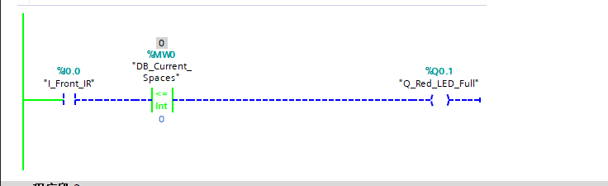
Network 1 — Entrance Interlock and Red Warning LED Actuation
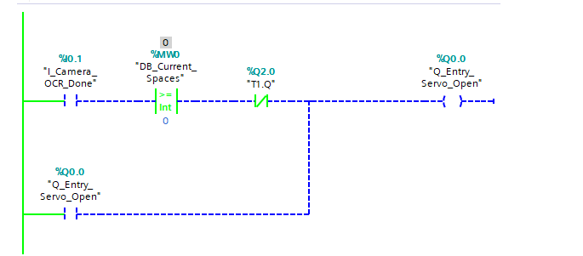
Network 2 — Entry Gate Servo Lifting Coil with Self-Retaining Contact
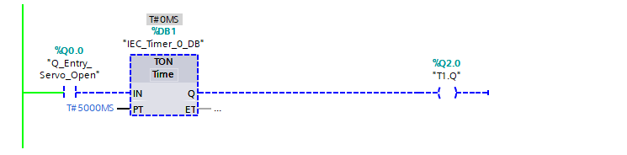
Network 3 — Non-Blocking On-Delay Timer (TON) for Entry Gate Clearance
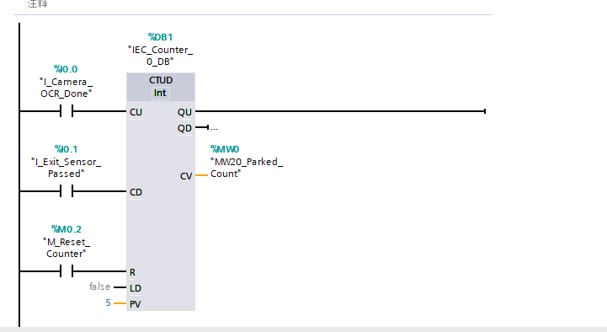
Network 4 — Bidirectional Up-Down Counter (CTUD) for Global Space Allocation
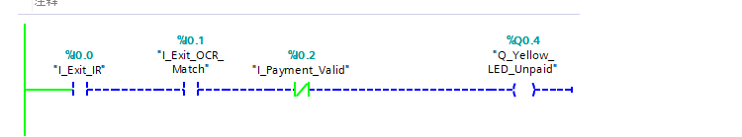
Network 5 — Tariff Exception Fault Interlock and Yellow Warning LED Actuation
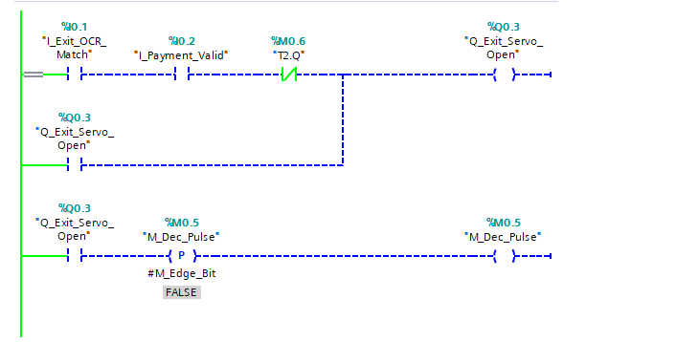
Network 6 — Exit Gate Servo Actuation and Decrement Pulse Logic
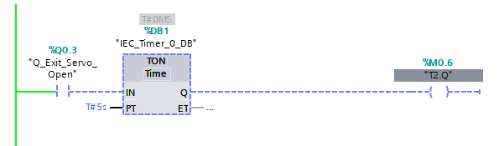
Network 7 — Non-Blocking On-Delay Timer (TON) for Exit Barrier Clearance
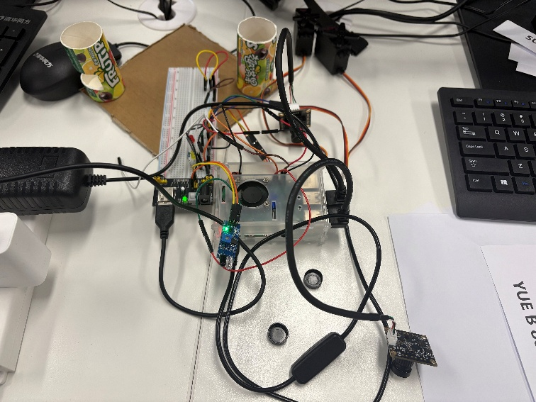
Appendix C Figure 5.1
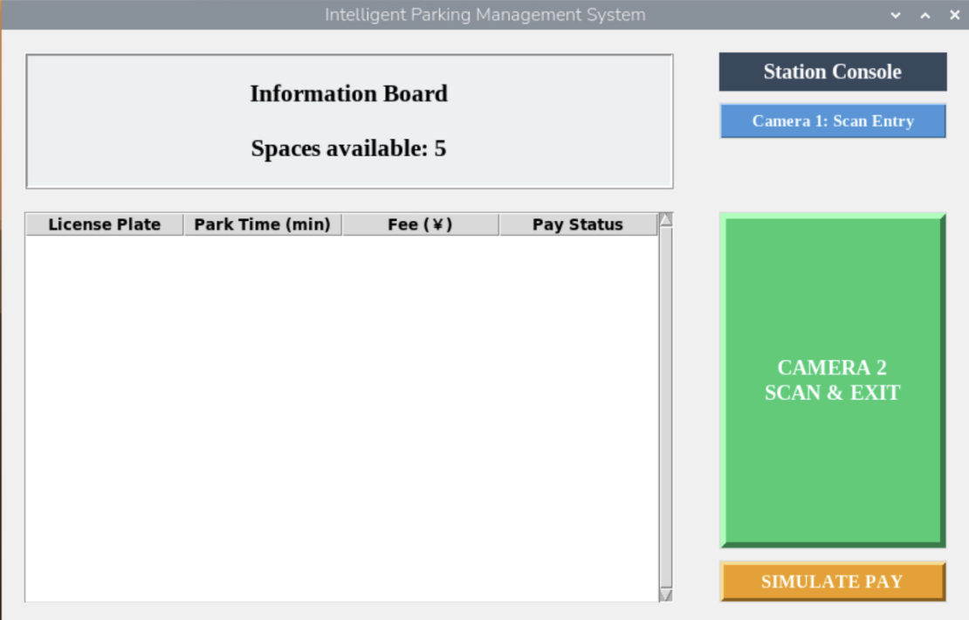
Figure 5.2: User Interface and Operational Monitoring
Appendix C (Table 6.1)
Test Case ID | Operational Scenario / Stimulus | Expected Systemic Behavior | UI Response | Status
TC-01 | Vehicle arrival at the entrance lane threshold; active-low interrupt tripped (GPIO 6 / %I0.0 = LOW). Space counter > 0. | Triggers Camera Node 0 for 11-frame OCR; logs $t_{entry}$in DB; drives GPIO 14 (%Q0.0) to 10.0% PWM duty cycle for 5s. | String authenticated; database entry logged; servo actuated smoothly to ${90}^{o}$prior to automatic recovery. | Passed
TC-02 | Saturation state enforced: active vehicle tracking reaches maximum capacity (N = 5). Subsequent vehicle attempts entry. | Evaluates Spaces ≤ 0: bypasses camera OCR, inhibits entry servo, and drives GPIO 21 (%Q0.1) to HIGH. | Gate progression locked; HMI status updated to "FULL"; Red Warning LED turned HIGH immediately. | Passed
TC-03 | Vehicle arrives at exit (GPIO 19 / %I0.2 = LOW); plate queried with no payment record or $∆t>180$. | Throws TARIFF_FAULT: holds exit servo at 5.5% duty cycle, drives GPIO 20 (%Q0.4) HIGH, and triggers admin prompt. | Exit barrier held static; Yellow Warning LED activated; HMI modal blocked checkout until manual settlement. | Passed
TC-04 | Exit validation: transaction processed within the 180-second validity window ($∆t≤180$). | Verifies payment; opens exit servo via GPIO 13 (%Q0.3) at 10.0% duty cycle; increments spaces; purges volatile node. | Exit gate lifted for 5s window; database decremented active count; memory cleared with zero heap bloating. | Passed

